

CLIENT: | Thelen CDJR | PHONE #:
SPOT: | THEL-CD-T210601 June Freedom Days | FAX # :
LENGTH: | :30 | SALES REP: | Larry H.
DATE: | 6/4/2021 | PRODUCER | A. Dennis

GRAPHICS | Video | AUDIO
Thelen Chrysler Logo  Euclid Ave. - Bay City  www.thelenchryslerjeepdodge.com  (Chrysler, Dodge, Jeep, Ram Logos)  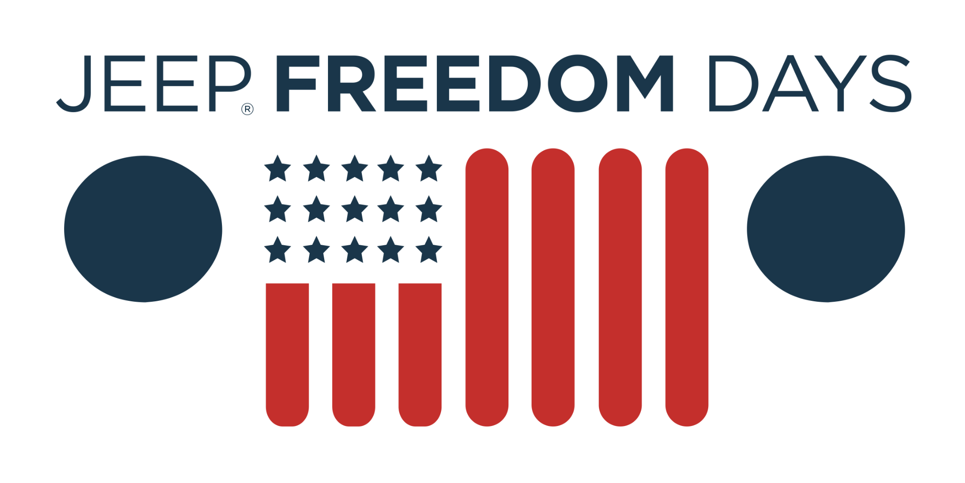  2021 Jeep Renegade Limited  Lease From Just $300/mo  Lease for 36 months, 10,000 miles per year with approved credit. $3,799 cash down or trade equity due at signing. Tax and fees extra. Must qualify for all available rebates and incentives. Picture may not represent the actual vehicle. See Thelen Chrysler for details. Ends 6/30/2021.  2021 Ram 1500 Big Horn Crew Cab  Lease From Just $359/mo  Includes Level 1 Equipment. Lease for 36 months, 10,000 miles per year with approved credit. $3,153 cash down or trade equity due at signing. Tax and fees extra. Must qualify for all available rebates and incentives. Picture may not represent the actual vehicle. See Thelen Chrysler for details. Ends 6/30/2021.  Thelen Chrysler Logo  Euclid Ave. - Bay City  www.thelenchryslerjeepdodge.com  (Chrysler, Dodge, Jeep, Ram Logos) | GFX: 2021 Jeep Freedom Days (logo)  GFX: 2021 Jeep Renegade Limited  GFX: 2021 Ram 1500 Big Horn Crew Cab | Announcer: (:30)  Thelen Chrysler Dodge Jeep Ram in Bay City always strives to get you more!  More savings!  More vehicle for your money!  And more for your trade-in!  Because it’s the right thing to do!  During Jeep Freedom Days, save on a new Jeep Renegade Limited! Now from just $300 a month!  Or upgrade to a new Ram 1500 Big Horn for less! Drive yours for just $359 a month!  Thelen Chrysler Dodge Jeep Ram. Euclid avenue, Bay City!  Getting you more for your money... because it’s the right thing to do!

